**T. Y. B. Tech (Electrical and Computer Engineering)**

**Trimester: V Subject: Microcontroller and Applications**

**Name: Shreerang Mhatre Class: TY**

**Roll No: 52 Batch: 3**

**Experiment No: 06**

**Name of the Experiment:** Programming of on chip ADC

**Marks**

**Teacher’s Signature with date**

**Performed on: 21/11/2023**

**Submitted on: 24/11/2023**



**Aim:** Write C program for programming of on chip ADC of C8051F340.

**Apparatus:** EPBF340 Board, ASK25 board, Connectors

**Theory:**

Analog to digital converter is among the most widely used device for data acquisition. It is used to convert the analog signals to digital numbers so that microcontroller can read and process them.

On-chip ADC Features:

* 10-Bit ADC
* Up to 200 ksps
* Built-in analog multiplexer with single-ended and differential mode
* VREF from external pin, internal reference, or VDD

**Interfacing Diagram:**

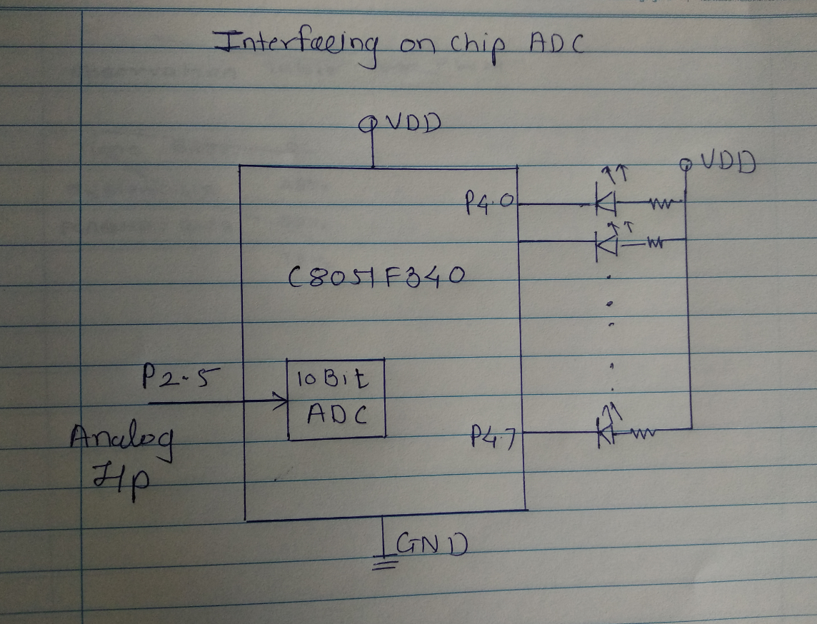

*Figure 5.1 Interfacing Diagram for onchip ADC programming*

**Algorithm:**

**Hardware Connections:** Connect single lead wire between P2.5 (Pin15 of PL3 connector) of EPBF340 board and Pin1 of PL10 connector of ASK25. To provide the ground also connect 20pin flat cable between PL6 connector of EBF340 board and PL8 connector of ASK25.

Connect USB cable between PL8 connector of EPBF340 board and PC.

|  |  |
| --- | --- |
| **F340 Reference** | **Device ASK25** |
| P2.5 (Pin15 of PL3 connector) | Pin 1 of PL10 connector (Pot RV2) |
| PL6 | PL8 |

**Program:** Attach the tested code.

**Calculations:**

Dout= (Vin/Vref)*1023

Table 1

|  |  |  |  |
| --- | --- | --- | --- |
| **Vin(Given)** | **Dout (Decimal)** | **Dout (Hex)** | **Dout (Binary)** |
| **3.3 V** | **1023** | **3FF** | **1111111111** |
| **1V** |  |  |  |
| **2.3V** |  |  |  |
| **2V** |  |  |  |
| **1.3 V** |  |  |  |

Table 2

|  |  |  |  |
| --- | --- | --- | --- |
| **Dout (Binary)** | **Dout (Hex)** | **Dout (Decimal)** | **Vin (Calculated)** |
| **0011101101** |  |  |  |
| **1110001100** |  |  |  |
| **0101100110** |  |  |  |
| **1100011100** |  |  |  |
| **1010011011** |  |  |  |
| **1111111111** |  |  |  |

**Conclusion:**

**------------------------------------------------------------------------------------------------------------------------------------------------------------------------------------------------------------------------------------------**

**Study Question:**

1. Give the main factor affecting the step size of ADC in C8051F340.

2. Give the formats for control registers associated with C8051F340 ADC.

**Interfacing Diagram:**

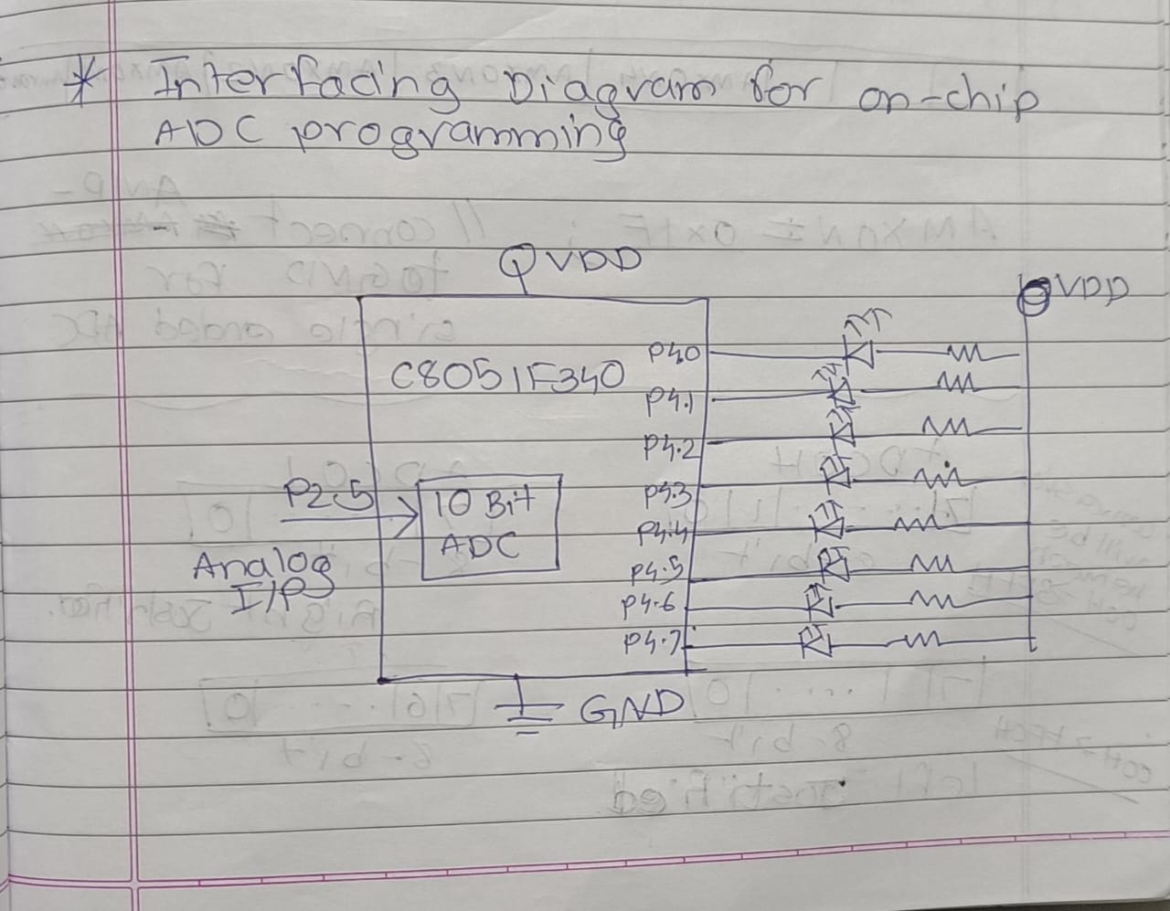

**Code For ADC:**

// Exp - 5 ADC Interfacing with C8051F340

/*

Name: Shreerang Mhatre

Rollno: 52

Batch: A3

Class: TY

*/

#include "C8051F340.h"

#define SYSClk 12000000

sbit Buzzer= P3^3;

void delay(unsigned int Ms);

void main()

{

    XBR1= 0X40;

    P4MDOUT= 0XFF;

    www.mitwpu.edu.in

    Buzzer= 0;

    P2SKIP= 0X20;

    P2MDIN= 0XD0;

    AMX0P= 0X04;

    AMX0N= 0x1F;

    ADC0CF= (((SYSClk/3000000)-1)<<3);

    REF0CN= 0x08;

    ADC0CN= 0x80;

    AD0EN= 1;

    {

        ADC0CN =0x90;

        while (AD0BUSY == 1);

        delay(50);

        P4= ~ ADC0L;

        delay(50);

        P4= ~ ADC0H;

        delay(50);

    }

while(1);

}

void delay(unsigned int Ms)

{

    unsigned int n;

    unsigned int i;

    for (n-0; n<Ms; n++)

    {

        for (i=0; i<65; i++);

        www.mitwpu.edu.in

    }

}

**Demonstration Of ADC:**

